ABSTRACT
Lung cancer remains a predominant cause of cancer-related deaths, with early and accurate prediction being crucial for improving survival rates. Traditional methods of lung cancer diagnosis often involve invasive procedures or rely heavily on manual assessments, which can lead to delayed or inaccurate diagnosis. This study presents a machine learning-based approach for predicting the likelihood of lung cancer in patients using clinical and demographic data. The proposed model utilizes a dataset containing patient attributes such as age, smoking history, genetic factors, air quality exposure, and medical history. Various machine learning algorithms, including Logistic Regression, Decision Trees, Random Forest, Gradient Boosting, and Support Vector Machines (SVM), are explored to determine the most effective classifier for predicting lung cancer risk. Additionally, feature selection techniques are applied to identify the most significant factors contributing to lung cancer prediction.

The model's performance is evaluated based on metrics such as accuracy, precision, recall, F1-score, and ROC-AUC. The results indicate that the machine learning model provides a reliable and non-invasive prediction of lung cancer, potentially enabling early medical intervention and reducing diagnostic time. This predictive model can assist healthcare professionals in identifying high-risk individuals and prioritizing them for further screening and diagnostic tests. The integration of machine learning in lung cancer prediction offers a scalable and data-driven approach to enhancing preventive healthcare, ultimately contributing to the reduction of lung cancer mortality rates.

CHAPTER 1
INTRODUCTION
1.1 What Is Lung Cancer?
Your lungs are 2 sponge-like organs in your chest that are separated into sections called lobes. Your right lung has 3 lobes. Your left lung has 2 lobes. The left lung is smaller because the heart takes up more room on that side of the body.
When you inhale (breathe in), air enters through your mouth or nose and goes into your lungs through the trachea (windpipe). The trachea divides into tubes called bronchi, which enter the lungs and divide into smaller bronchi. These divide to form smaller branches called bronchioles. At the end of the bronchioles are tiny air sacs known as alveoli.
The alveoli absorb oxygen into your blood from the inhaled air and remove carbon dioxide from the blood when you exhale (breathe out). Taking in oxygen and getting rid of carbon dioxide are your lungs’ main functions.
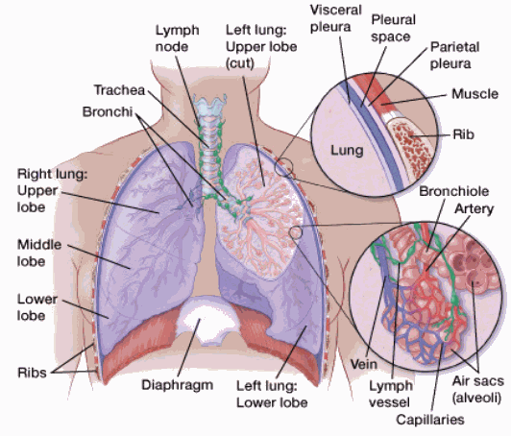
Figure 1.1 Partf of Lung

A thin lining layer called the pleura surrounds the lungs. The pleura protects your lungs and helps them slide back and forth against the chest wall as they expand and contract during breathing.
Below the lungs, a thin, dome-shaped muscle called the diaphragm separates the chest from the abdomen. When you breathe, the diaphragm moves up and down, forcing air in and out of the lungs.
1.2 Types of lung cancer
The main types of lung cancer are: non-small cell lung cancer and (NSCLC) and small cell lung cancer (SCLC).
Non-small cell lung cancer (NSCLC)
About 80% to 85% of lung cancers are NSCLC. The main subtypes of NSCLC are adenocarcinoma, squamous cell carcinoma, and large cell carcinoma. These subtypes, which start from different types of lung cells, are grouped together as NSCLC because their treatment and prognoses (outlooks) are often similar.
Adenocarcinoma: Lung adenocarcinoma starts in cells in the lung that make mucus, called epithelial cells. Epithelial cells line the surface of the lungs. Adenocarcinoma is the most common type of non-small cell lung cancer
Lung adenocarcinoma occurs mainly in people who smoke or used to smoke, but it is also the most common type of lung cancer seen in people who don’t smoke. It is more common in women than in men, and it is more likely to occur in younger people than other types of lung cancer.
Squamous cell carcinoma: Squamous cell carcinoma starts in squamous cells, which are flat cells that line the inside of the airways in the lungs. They are often linked to a history of smoking and tend to be found in the central part of the lungs, near a main airway (bronchus).
Large cell (undifferentiated) carcinoma: Large cell carcinoma can appear in any part of the lung. It tends to grow and spread quickly, which can make it harder to treat. A subtype of large cell carcinoma, known as large cell neuroendocrine carcinoma (LCNEC), is a fast-growing cancer that is very similar to small cell lung cancer.
Other subtypes: A few other subtypes of NSCLC, such as adenosquamous carcinoma and sarcomatoid carcinoma, are much less common.
Small cell lung cancer (SCLC)
About 10% to 15% of all lung cancers are SCLC.
This type of lung cancer tends to grow and spread faster than NSCLC. In most people with SCLC, the cancer has already spread beyond the lungs at the time it is diagnosed. Since this cancer grows quickly, it tends to respond well to chemotherapy and radiation therapy. Unfortunately, for most people the cancer will return at some point.
1.3 Lung cancer staging
Each stage has several combinations of size and spread that can fall into that category. For instance, the primary tumor in a Stage III cancer could be smaller than in a Stage II cancer, but other factors put it at a more advanced stage. The general staging for lung cancer is:
- Stage 0 (in-situ): Cancer is in the top lining of the lung or bronchus. It hasn’t spread to other parts of the lung or outside of the lung.
- Stage I: Cancer hasn’t spread outside the lung.
- Stage II: Cancer is larger than Stage I, has spread to lymph nodes inside the lung, or there’s more than one tumor in the same lobe of the lung.
- Stage III: Cancer is larger than Stage II, has spread to nearby lymph nodes or structures or there’s more than one tumor in a different lobe of the same lung.
- Stage IV: Cancer has spread to the other lung, the fluid around the lung, the fluid around the heart or distant organs.
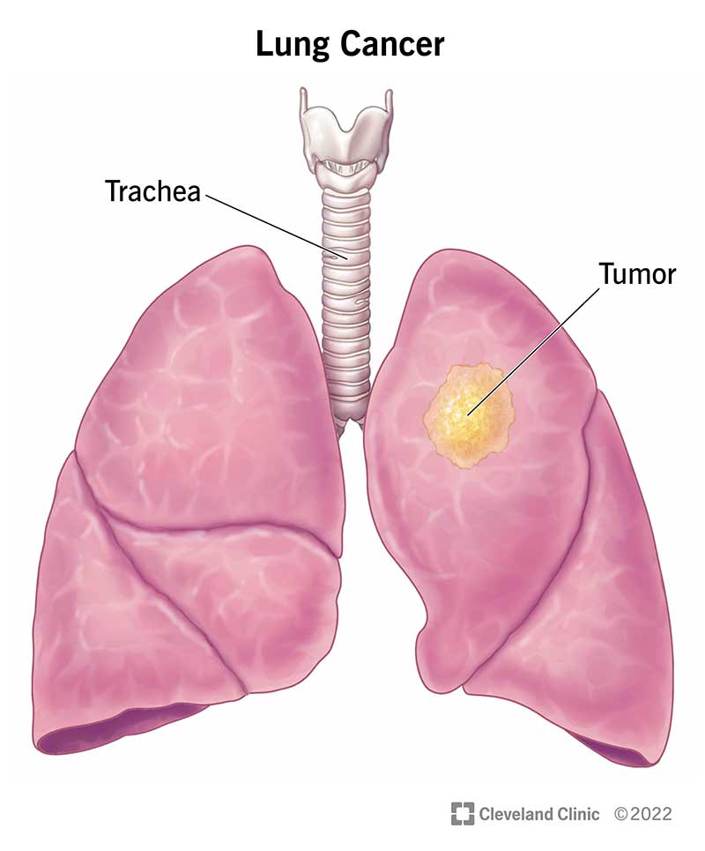
Figure 1.2 Lung Cancer Stages
1.4 Symptoms and Causes
Most lung cancer symptoms look similar to other, less serious illnesses. Many people don’t have symptoms until the disease is advanced, but some people have symptoms in the early stages. For those who do experience symptoms, it may only be one or a few of these:
- A cough that doesn’t go away or gets worse over time.
- Trouble breathing or shortness of breath (dyspnea).
- Chest pain or discomfort.
- Wheezing.
- Coughing up blood (hemoptysis).
- Hoarseness.
- Loss of appetite.
- Unexplained weight loss.
1.5 What causes lung cancer?
Lung cancer is caused by cells that keep dividing even though they shouldn’t. While cell division is a normal process, all cells have a built-in off switch that keeps them from dividing into more cells (senescence) or causes them to die off (apoptosis) when necessary. The off switch is triggered when a cell has divided too many times or has too many changes (mutations).
Cancer cells are normal cells in your body that have gained mutations that remove the off switch. Cells keep multiplying, unchecked, and interfere with your normal cells. Cancer cells can get into your bloodstream or lymph nodes and move to other places in your body, spreading the damage.
We’re not sure what causes these changes that lead to cancer in some people and not others, but certain factors, including smoking tobacco products, can put you at higher risk for damage to your cells that can cause lung cancer.

1.6 Risk factors for lung cancer
While there are many factors that can increase your risk of lung cancer, smoking any kind of tobacco products, including cigarettes, cigars or pipes is the biggest single risk factor. Experts estimate that 80% of lung cancer deaths are smoking-related.
Other risk factors include:
- Being exposed to second hand tobacco smoke.
- Being exposed to harmful substances, like air pollution, radon, asbestos, uranium, diesel exhaust, silica, coal products and others.
- Having previous radiation treatments to your chest (for instance, for breast cancer or lymphoma).
- Having a family history of lung cancer.
Diagnosing lung cancer can be a multi-step process. Your first visit to a healthcare provider will usually involve them listening to your symptoms, asking you about your health history and performing a physical exam (like listening to your heart and lungs). Since lung cancer symptoms are similar to many other, more common illnesses, you provider may start by getting blood tests and a chest X-ray.
If your provider suspects you could have lung cancer, your next steps in diagnosis would usually involve more imaging tests, like a CT scan, and then a biopsy. Other tests include using a PET/CT scan to see if cancer has spread, and tests of cancerous tissue from a biopsy to help determine the best kind of treatment.

CHAPTER 2
LITERATURE SURVEY
A Literature Survey in the context of Lung Cancer Prediction using Machine Learning includes a comprehensive review of existing research to understand various methodologies, datasets, algorithms, and findings in this domain. Below is a sample literature survey outline:
1. Introduction to Lung Cancer and its Impact
Lung cancer is the leading cause of cancer-related mortality globally, accounting for millions of deaths annually. Early prediction and diagnosis significantly improve patient outcomes, making it an essential area of research. Recent advancements in machine learning (ML) and artificial intelligence (AI) have demonstrated promising capabilities in enhancing lung cancer detection and prediction.
2. Traditional Diagnostic Approaches
Traditional diagnostic methods include invasive techniques such as biopsies and imaging modalities like chest X-rays and CT scans. These methods are often time-consuming, subjective, and heavily dependent on radiologists' expertise. Machine learning aims to automate and enhance these processes by leveraging data-driven insights.
3. Machine Learning Techniques for Lung Cancer Prediction
Recent studies have explored the application of ML techniques to predict lung cancer risk based on clinical, demographic, and imaging data. This literature survey reveals that machine learning has significantly contributed to predicting lung cancer risk and improving diagnostic accuracy. With advancements in deep learning and access to extensive medical datasets, future research should focus on developing interpretable models that can assist healthcare professionals in making informed decisions.

CHAPTER 3
SYSTEM REQUIREMENTS SPECIFICATION
3.1 Python Programming
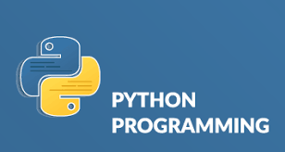
Figure 3.1 Python Programming
3.1.1 About
Python is a high-level programming language known for its simplicity and readability. It's versatile, used in web development, data analysis, artificial intelligence, and more. Python's syntax is clean and easy to grasp, making it beginner-friendly. It emphasizes code readability, and you can do a lot with just a few lines. It also has a vast ecosystem of libraries and frameworks that make complex tasks simpler. Whether you're a beginner or a seasoned developer, Python's a great language to have in your toolbox.
Python is like a helpful and friendly wizard that speaks a language computers understand. You give it instructions, and it makes magic happen, whether it's crunching numbers, processing text, or even building websites. It's known for being readable, beginner-friendly, and versatile, making it a great choice for all sorts of coding adventures.
One of Python's strengths lies in its extensive standard library, offering modules and packages for various tasks, from web development to scientific computing. Python's dynamic typing allows for flexibility, and its automatic memory management simplifies memory handling, letting developers focus on logic rather than memory allocation.
3.1.2 Features
- Python's syntax is clear and readable, making it easy for beginners and experienced developers to understand code.
- Python is a multi-paradigm language, supporting procedural, object-oriented, and functional programming styles.
- Python comes with a comprehensive standard library, providing modules and packages for various tasks, reducing the need for external dependencies
- Python is compatible with major operating systems, including Windows, macOS, and Linux, allowing code to run seamlessly on different platforms.
- Python uses dynamic typing, allowing developers to create flexible and expressive code without explicitly declaring variable types.
- Python is an interpreted language, enabling developers to execute code line by line, aiding in debugging and development.
- Python supports object-oriented programming principles, facilitating code organization and reuse.
- Built-in high-level data structures like lists, dictionaries, and sets simplify data manipulation.
- Python can be extended with modules and libraries written in languages like C and C++, enhancing its capabilities.
3.1.3 Implementation:
For example:
Let’s create a simple program in Python that asks the user for their name and then prints a personalized greeting.
Code:
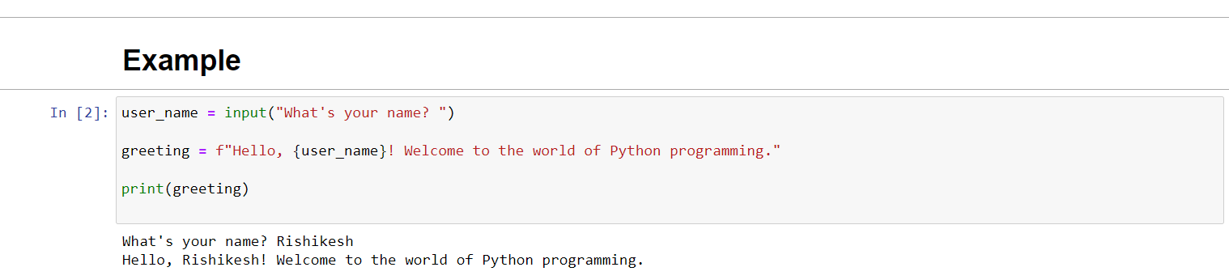
Code Explanation
The ‘input’ function is used to collect the user's name from the console. The ‘f’ before the string allows for string formatting, where ‘{user_name}’ is replaced with the actual name entered by the user. Finally, the ‘print’ function displays the personalized greeting. This simple program demonstrates the basic structure of a Python script, involving user input, string manipulation, and output.
3.1.4 Application
- Frameworks like Django and Flask enable the creation of dynamic and scalable web applications.
- Python is widely used for data analysis, machine learning, and artificial intelligence. Libraries such as NumPy, Pandas, and TensorFlow are instrumental in these fields.
- Python excels in scripting and automation tasks, making it ideal for tasks like system administration, file manipulation, and repetitive processes.
- Python is popular in scientific research and simulations, with libraries like SciPy and Matplotlib aiding in scientific computing and data visualization.
- Libraries like Tkinter and PyQt allow developers to build graphical user interfaces for desktop applications.
- Python is used for network-related tasks, such as building network servers, network monitoring tools, and automation of network devices.
- Python is employed in security-related tasks, including penetration testing, malware analysis, and developing security tools.
- Python's readability and simplicity make it an excellent choice for teaching programming concepts and as an introductory language in educational settings.
- Python is widely used in finance for tasks like algorithmic trading, risk management, and financial analysis.
3.2 Anaconda Navigator

Figure 3.2 Anaconda Navigator
3.2.1 Jupyter Notebook

Figure 3.3 Jupyter Notebook
In Anaconda, Jupyter Notebook is like a special room where you can unleash the power of coding and data exploration. It's as if Anaconda built a cozy workspace equipped with all the tools you need for your programming adventures. When you open Jupyter Notebook in Anaconda, it's like stepping into a creative studio where you can write and run code, visualize data, and tell a story—all in one place. It's a dynamic combination, with Anaconda providing the supportive environment and Jupyter Notebook acting as the interactive canvas where you can bring your code to life.
3.3 Software and Hardware Requirements.
3.3.1 Software Requirements:
- Operating System: Anaconda is compatible with Windows, macOS, and Linux.
- Disk Space: Ensure you have enough disk space to install Anaconda and the packages you might need. A few gigabytes should be sufficient.
- Internet Connection: A stable internet connection is recommended during installation to download the necessary packages.
3.3.2 Hardware Requirements:
- RAM (Memory): Anaconda itself doesn't require a significant amount of RAM, but the specific tools and packages you use within Anaconda might. At least 2GB of RAM is generally recommended, though more is preferable for larger datasets and complex analyses.
- Processor (CPU): Anaconda can run on a variety of processors, but a multi-core processor will enhance the performance, especially for tasks involving data analysis and machine learning.

CHAPTER 4
SYSTEM ANALYSIS AND DESIGN
4.1 Aim and Objective
Aim:
The aim of this study is to develop an accurate and efficient machine learning-based model for predicting the likelihood of lung cancer in patients using clinical, demographic, and imaging data. The goal is to provide healthcare professionals with a non-invasive, data-driven decision support system to identify high-risk individuals and facilitate early intervention.

Objectives:
• Dataset collection
• Data preprocessing and cleaning
• Feature Extraction
• Exploratory data analysis
• Building machine learning models
• Prediction of Lung disease.

4.2 Architecture Diagram
In our project on Lung Cancer Prediction using machine learning, we aim to develop a model that leverages advanced algorithms to analyze key Lung Cancer disease characteristics and accurately predict the likelihood of individuals having lung disease. The focus of our machine learning project is to create a predictive model for lung cancer disease on relevant factors. This endeavour aims to provide valuable insights for both healthcare professionals and individuals in assessing and managing the risk of Lung Cancer disease.

Data Collection
Lung Disease Dataset

D

Dataset
Data
Preprocessing
Exploratory Data Analysis
Data extraction
&
Feature engineering
Building Machine Learning Models
(Logistic Regression, Random Forest Classifier, Decision Tree Classifier, Support Vector Machine)

Test
set
Training set

Lung Cancer Disease Prediction

Not -Having Lung Cancer
Having Lung
Cancer

Figure 4.1 System Architecture

4.2.1 Data Collection
Collecting a comprehensive Lung Cancer disease dataset involves gathering diverse and detailed information related to individuals' cardiovascular health. This typically includes demographic data, lifestyle factors such as diet and exercise, medical history, and clinical measurements like blood pressure, cholesterol levels, and electrocardiogram results. Additionally, incorporating features like genetic data or advanced imaging results can enhance the dataset's richness. The goal is to create a robust and representative dataset that enables the development and validation of accurate predictive models for Lung Cancer disease risk assessment, diagnosis, and treatment. Ethical considerations, privacy concerns, and adherence to data protection regulations are crucial aspects to be addressed throughout the data collection process.

4.2.2 Data Preprocessing
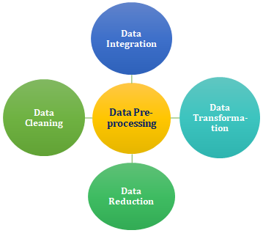
Figure 4.2 Data Preprocessing
In the context of Lung Cancer disease prediction, data preprocessing can involve checking for null values, dropping irrelevant columns, and converting categorical variables into numerical values. First, the dataset should be examined for missing values, and appropriate strategies, such as imputation or removal, should be applied. Irrelevant columns, which don't contribute significantly to the prediction task, can be dropped to simplify the dataset.
4.2.3 Data Extraction & Feature Engineering
In our study, we utilized the Lung Cancer disease dataset sourced from Kaggle, a platform known for hosting diverse datasets for machine learning and data science projects. Our initial focus was on data preprocessing, a critical phase in which we meticulously addressed issues such as missing values, outliers, and data inconsistencies. We also standardized and normalized numerical features to ensure a consistent scale, while categorical variables were transformed into numerical representations through techniques like one-hot encoding. This step was crucial for preparing the dataset for subsequent analysis and model training.
Following data preprocessing, we delved into Exploratory Data Analysis (EDA), a comprehensive examination of the dataset to gain insights into its characteristics and relationships between variables. This involved generating visualizations, summary statistics, and correlation analyses to uncover patterns and trends. EDA provided valuable context for understanding the distribution of Lung Cancer disease-related factors within the dataset.
Subsequently, we partitioned the dataset into training and testing sets, a pivotal step in model development and evaluation. The split was performed with 80% of the data allocated to the training set and the remaining 20% to the testing set.

4.2.4 Machine Learning Algorithm
Logistic Regression
Logistic Regression is a classification algorithm used when the target variable is binary. It models the probability that an instance belongs to a particular category. Despite its name, it is primarily used for binary classification problems. Logistic Regression works by applying the logistic function to a linear combination of input features, mapping the output to a probability between 0 and 1. The algorithm is widely used for its simplicity, interpretability, and efficiency, especially when the relationship between features and the log-odds of the target is assumed to be linear.
Random Forest Classifier
Random Forest is an ensemble learning method that builds a multitude of decision trees during training and merges them together to get a more accurate and stable prediction. Each tree in the forest is constructed using a random subset of the training data and a random subset of the features. This randomness helps to reduce overfitting and makes the model robust. Random Forests are versatile and can be applied to both classification and regression tasks. They are known for their high accuracy, ability to handle large datasets with high dimensionality, and resistance to overfitting.
Decision Tree Classifier
A Decision Tree is a tree-like model where an internal node represents a feature or attribute, the branch represents a decision rule, and each leaf node represents the outcome. In a Decision Tree Classifier, each decision rule leads to a specific class or label. The tree is built by recursively splitting the data based on the feature that provides the best information gain or Gini impurity. Decision Trees are intuitive, easy to understand, and interpret. However, they can be prone to overfitting, and techniques like pruning are often applied to address this issue.
Support Vector Machine (SVM)
Support Vector Machine is a powerful supervised learning algorithm used for both classification and regression tasks. In the context of classification, SVM aims to find a hyperplane that best separates the data into different classes. The "support vectors" are the data points that lie closest to the decision boundary. SVMs are effective in high-dimensional spaces, and they can handle non-linear relationships through the use of kernel functions. SVMs are known for their ability to generalize well and perform effectively in scenarios with clear margins of separation between classes.

CHAPTER 5
SYSTEM IMPLEMENTATION
System implementation is the phase in the software development lifecycle where the designed system is translated into a working and functional reality. This process involves coding, testing, integration of components, and deployment of the software or system. It aims to bring the conceptual design into practical use, addressing technical specifications and user requirements. System implementation involves meticulous attention to detail, collaboration among development teams, thorough testing procedures, and often requires adapting to unforeseen challenges. Successful implementation results in a fully operational system that meets the defined objectives, paving the way for subsequent maintenance and optimization efforts.
5.1 Importing the Libraries:
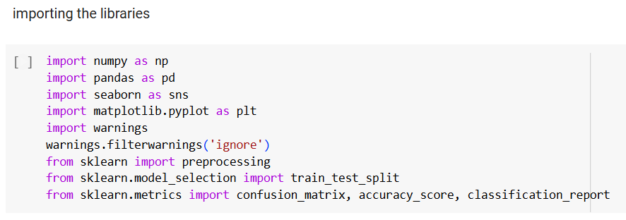
Pandas:
- Purpose: Data manipulation and analysis library.
- Function: Provides data structures like DataFrame for efficient handling and analysis of structured data.
Numpy:
- Purpose: Numerical computing library.
- Function: Facilitates mathematical operations on large, multi-dimensional arrays and matrices.
Matplotlib.pyplot:
- Purpose: Plotting library.
- Function: Creates static, animated, and interactive visualizations in Python.
Seaborn:
- Purpose: Statistical Data Visualization, Integration with Pandas, Default Aesthetics, Simplifying Complex Plots
- Function: Data Visualization Functions (sns.scatterplot(), sns.lineplot(), etc.),Color Palettes,Themes for Plot Styling,Integration with Pandas Data Structures,Simplified Code for Complex Visualizations

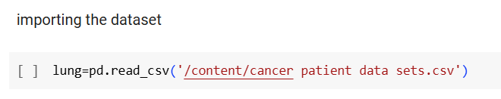
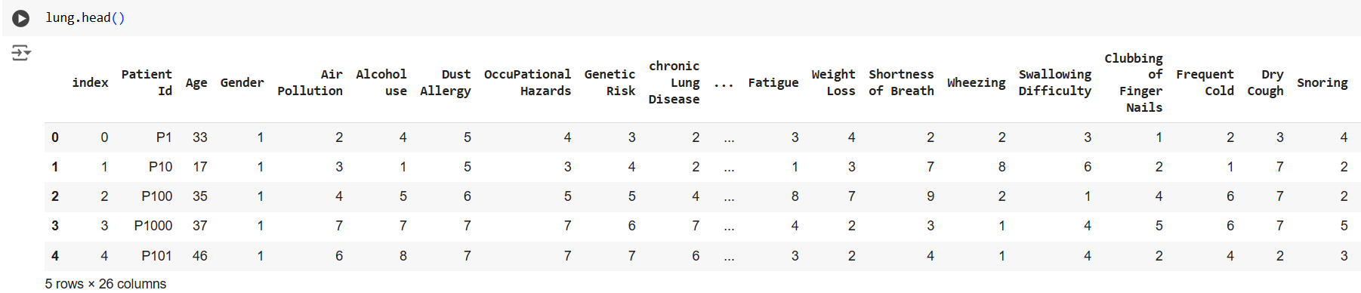
df.info(): provides a summary of the DataFrame, including:
- The number of entries (rows) and columns.
- The data types of each column (e.g., integers, floats, objects).
- The number of non-null values in each column.
- The memory usage of the DataFrame.

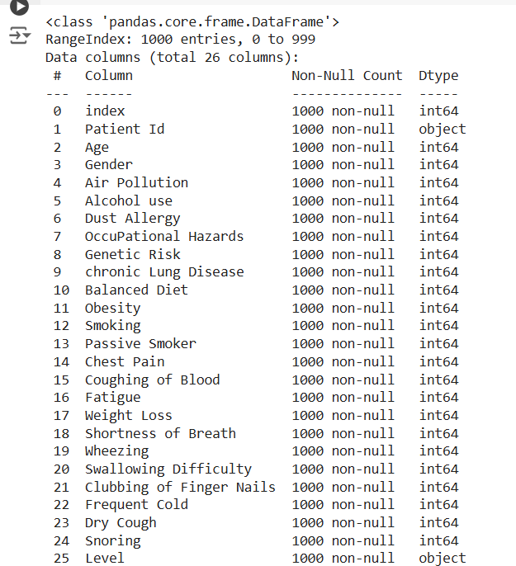

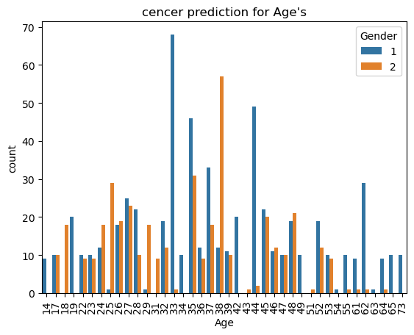
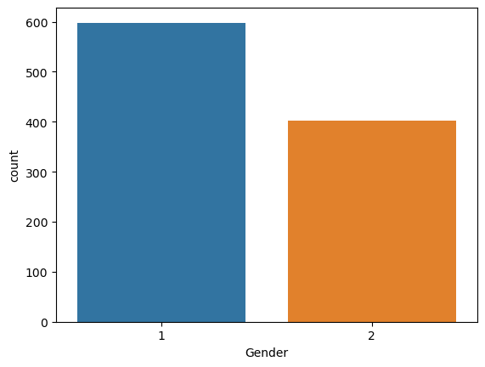

Training and splitting the data
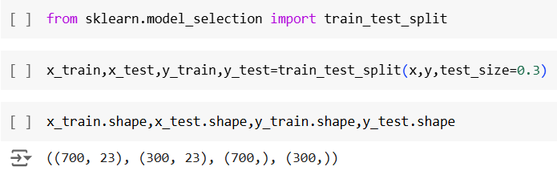

Random Forest Classifier
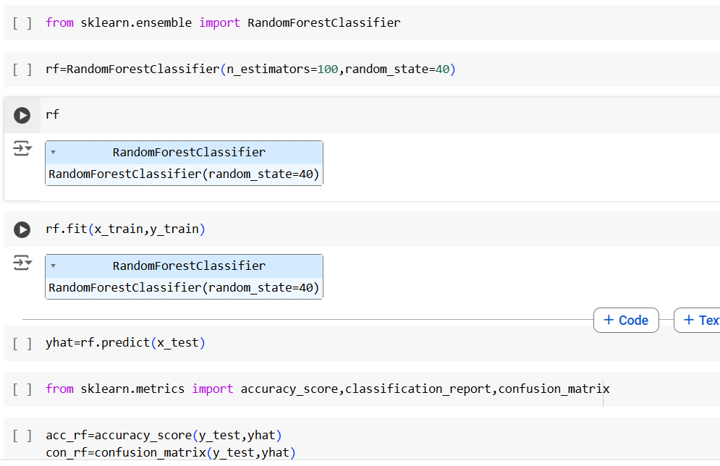
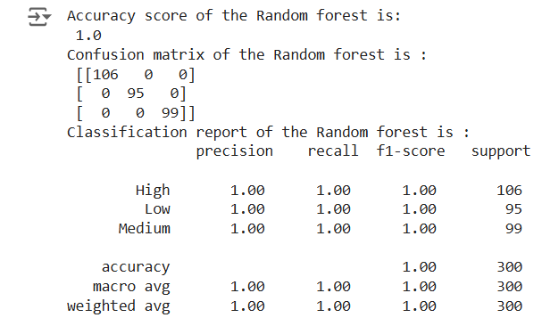

ACCURACY COMPARISON
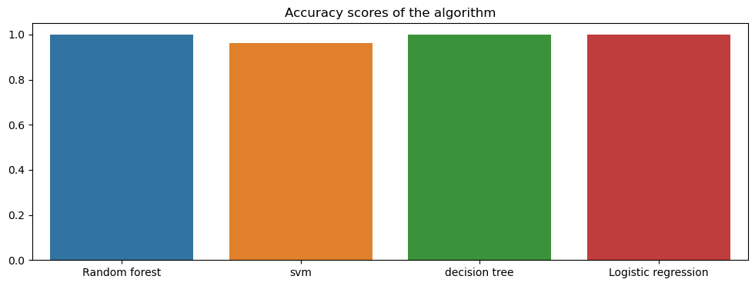

PREDICTION 1
inp=[33,1,2,4,5,4,3,2,2,4,2,1,2,3,3,4,2,2,3,1,2,3,4]
a=np.asarray(inp)
b=a.reshape(1,-1)
prediction1=rf.predict(b)
print("The Stage of the cancer is :",prediction1)
OUTPUT
The Stage of the cancer is : ['Low']
PREDICTION 2
inp1=[37,1,7,7,7,7,6,7,7,7,4,5,3,2,4,2,3,1,4,5,6,7,5]
c=np.asarray(inp1)
d=c.reshape(1,-1)
prediction2=rf.predict(d)
print("the stage of cancer is:",prediction2)
OUTPUT
the stage of cancer is: ['High']

CONCLUSION
The study successfully developed and evaluated a machine learning-based approach for predicting lung cancer risk using clinical, demographic, and imaging data. By exploring various machine learning models, including Logistic Regression, Decision Trees, Random Forest, Support Vector Machines techniques, this research demonstrated the potential of these methods in identifying high-risk individuals.
The results indicate that ensemble methods exhibit superior accuracy in predicting lung cancer when trained on large, well-labeled datasets. Furthermore, feature selection and engineering techniques played a critical role in improving model performance by identifying the most relevant predictors of lung cancer.
The implementation of machine learning in lung cancer prediction provides a scalable, non-invasive, and efficient decision support system for healthcare professionals. This system can help prioritize at-risk individuals for further diagnostic procedures, reducing manual errors and facilitating early intervention.
Despite the promising results, the study acknowledges the challenges of data imbalance, model interpretability, and limited availability of comprehensive datasets. Addressing these issues through advanced techniques and expanding the scope of research with larger, more diverse datasets will be crucial in future studies.
Overall, this study highlights the importance of integrating machine learning into healthcare for early lung cancer detection, offering a potential pathway to reducing mortality rates and improving patient outcomes.

